

Programme Name: **BCS**

Course Code: **CSC 1612**

Course Name: **DATA COMMUNICATION AND NETWORKING**

**Internal Examination**

Date of Submission: **9/22/2020**

**Submitted By: Submitted To:**

Student Name: **Dipesh Tha Shrestha** Name: **SATYAM PAUDEL**

IUKL ID: **041902900028** Department: **LMS**

Semester: **Second**

Intake**: 2019 September**

1. a. With an IPv4 addressing there are five classes of available IP ranges: Class A, Class B, Class C, Class D and Class E, while only A, B, and C are commonly used. Each class allows for a range of valid IP addresses. Complete the table with range of valid IP address in each class.

Class Range Class A ------------- to -------------- Class B ------------- to -------------- Class C ------------- to -------------- Class D ------------- to -------------- Class E ------------- to --------------

**Answer:**

With an IPv4 IP address, there are five classes of available IP ranges: Class A, Class B, Class C, Class D and Class E, while only A, B, and C are commonly used. Each class allows for a range of valid IP addresses, shown in the following table.

|  |  |
| --- | --- |
| Class | Address range |
| **Class A** | 1.0.0.1 to 126.255.255.254 |
| **Class B** | 128.1.0.1 to 191.255.255.254 |
| **Class C** | 192.0.1.1 to 223.255.254.254 |
| **Class D** | 224.0.0.0 to 239.255.255.255 |
| **Class E** | 240.0.0.0 to 254.255.255.254 |

Ranges 127.x.x.x are reserved for the loopback or localhost, for example, **127.0.0.1** is the loopback address. Range **255.255.255.255** broadcasts to all hosts on the local network.

b. Given IP address 172.25.171.182 /19, Write the network and broadcast address for the network.

|  |  |  |  |  |
| --- | --- | --- | --- | --- |
| **IPv4 Address (in decimals)** | 10 | 220 | 122 | 80 |
| **IPv4 Address (in binaries)** | 00001010 | 11011100 | 01111010 | 01010000 |
| **Subnet Mask (in decimals)** | 255 | 128 | 0 | 0 |
| **Subnet Mask (in binaries)** | 11111111 | 10000000 | 00000000 | 00000000 |
| **Network Address (in binaries) (all bits in host part are "0")** | 00001010 | 10000000 | 00000000 | 00000000 |
| **Network Address (in decimals)** | 10 | 128 | 0 | 0 |
| **Directed Broadcast Address (in binaries) (all bits in host part are "1")** | 00001010 | 11111111 | 11111111 | 11111111 |
| **Directed Broadcast Address (in decimals)** | 10 | 255 | 255 | 255 |

Network Address in binaries - 10101100.00011001.10100000.00000000 (equal to 172.25.160.0 in decimals)

Broadcast Address in binaries - 10101100.00011001.10111111.11111111 (equal to 172.25.191.255 in decimals)

The network and broadcast address for the network is given below:

**Network Address** : 172.25.160.0

**Directed Broadcast Address** : 172.25.191.255

c. Write the directed broadcast address of IPv4 address 10.2.122.17 with the default Class A subnet mask of 255.0.0.0.

Answer: Directed broadcast address is a special IPv4 address used as the destination address in IPv4 datagram packet  for directed broadcasts.

Directed broadcast address is the last address of an IPv4 address block. Directed broadcast addresses are derived by setting all the host bits in an IPv4 address block as binary number, "1".

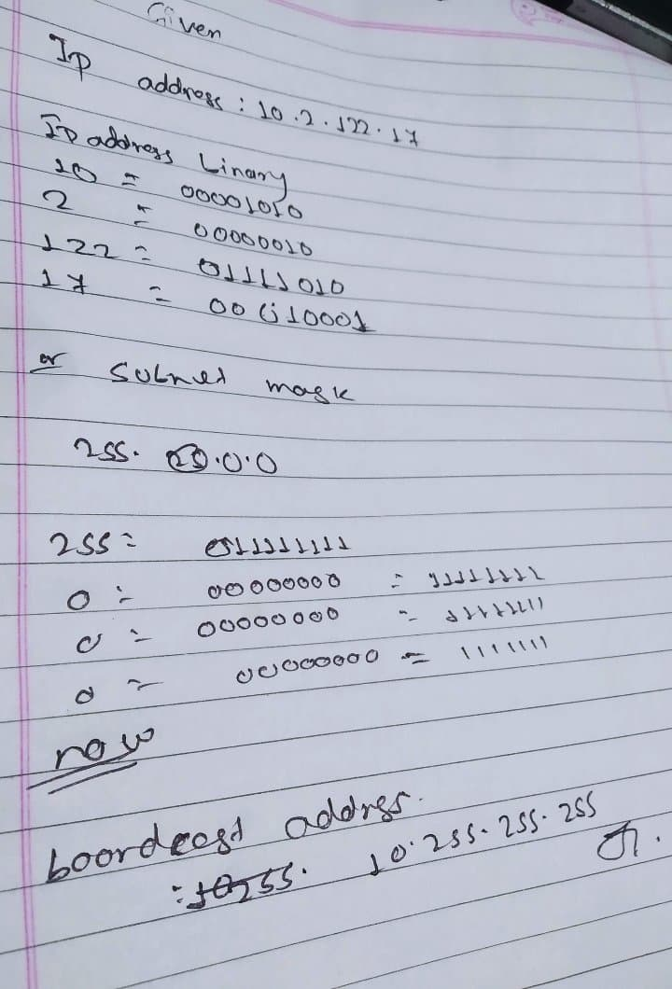

The directed broadcast address of IPv4 address 10.2.122.17 with the default Class A subnet mask of 255.0.0.0 is 10.255.255.255

2. An IT company in London has hired you as a Network Engineer. As a part of the job, you have been requested to configure cisco switches. Write complete command to configure the switches.

a. Name of the switch to LondonTech_Level1

**Switch>enable**

**Switch#config terminal**

**Enter configuration commands, one per line.End with CNTL/Z.**

**Switch(config) #hostname LondonTech_Level1**

**LondonTech_Level1 (config)#**

b. Set console password as PA55w0rd

**Switch>enable**

**Switch#config terminal**

**Enter configuration commands, one per line. End with CNTL/Z**

**Switch(config) #Line console 0**

**Switch(config-line) #password PA55w0rd**

**Switch(config-line) #login**

**Switch(config-line) #**

c. Set banner message as “You are not an authorized user. Strict action will be taken”.

**Switch>enable**

**Switch#config terminal**

**Enter configuration commands, one per line. End with CNTL/Z.**

**Switch(Config) #banner motd # You are not an authorized user. Strict action will be taken #**

d. Assign IP address to Interface Fast Ethernet 0/0. The IP address is 200.182.119.1 and subnet mask is 255.255.255.224. Also, change the state to active mode.

**Switch>enable**

**Switch#config terminal**

**Enter configuration commands, one per line.End with CNTL/Z.**

**Switch(config) #interface gigabitEthernet 0/0/0**

**Switch(config-if) #ip address 200.182.119.1 255.255.255.224**

**Switch(config-if) #no shutdown**

**Switch(config-if) #%LINK-5-CHNAGED: Interface GigabitEthernet0/0/0, Changed state to up**

**%LINEPROTO-5_UPDOWN: Line protocol on Interface GigabitEthernet0/0/0, Changed state to up**

e. Set VTY password as vtyPa55wor

**Switch>enable**

**Switch#config terminal**

**Enter configuration commands, one per line.End with CNTL/Z.**

**Switch(config) #Line VTY 0 4**

**Switch(config-line) #password vtyPa55wor**

**Switch(config-line) #login**